Table of Contents
1. What is Android ? 1
2. What are the features of Android Platform ? 1
3. What is the Architecture of Android ? 1
3.1. Linux Kernel 2
3.1.1. Key Points: 2
3.2. Android Runtime & Core API’s 2
3.2.1. Android Runtime 2
3.2.2. Core APIs 2
3.3. Libraries 2
3.4. Application Framework 3
3.5. Applications 3
4. Android Applications 3
4.1. Fundamentals 3
4.2. Application – Components 2
4.2.1. Activity 3
4.2.2. Services 3
4.2.3. Broadcast Receivers 4
4.2.4. Content Providers 4
4.3. Activating & Shutdown Components 4
4.3.1. Activating Components: Intents 4
4.3.2. Shutting Down Components 5
4.4. Others 5
4.4.1. The Manifest file 5
4.4.2. Intents, Intent Objects and Intent filters 6
5. Activities & Tasks 9
6. Processes and Threads 10
6.1. Process 10
6.2. Threads 11
7. Switching to Home Screen 11

List of Figures
Figure 1. Architecture of Android Operating System 2
Figure 2. Building blocks of an Application 2
Figure 3. Boot up process 11
Figure 4. Boot up Process - 2 12
Figure 5. Home Screen Launching Process 13

List of Tables

Table 1. Action Constants 7
Table 2. Category Constants 8

- What is Android ?
- Android is a software stack for mobile devices that includes an operating system, middleware and key applications.
- The Android SDK provides the tools and APIs necessary to begin developing applications on the Android platform using the Java programming language.

- What are the features of Android Platform ?
- Application framework enabling reuse and replacement of components
- Dalvik virtual machine optimized for mobile devices
- Integrated browser based on the open source WebKit engine
- Optimized graphics powered by a custom 2D graphics library; 3D graphics based on the OpenGL ES 1.0 specification (hardware acceleration optional)
- SQLite for structured data storage
- Media support for common audio, video, and still image formats (MPEG4, H.264, MP3, AAC, AMR, JPG, PNG, GIF)
- GSM Telephony (hardware dependent)
- Bluetooth, EDGE, 3G, and WiFi (hardware dependent),NFC (hardware dependent),
- Camera, GPS, compass, and Sensors like accelerometer (hardware dependent)
- Rich development environment including a device emulator, tools for debugging, memory and performance profiling, and a plugin for the Eclipse IDE,Android Studio.

- What is the Architecture of Android ?
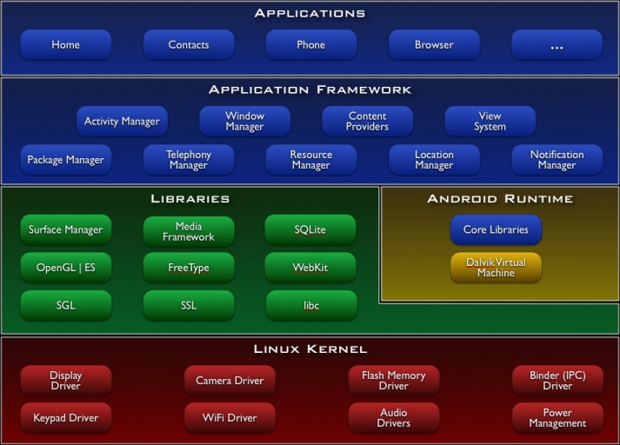
- Architecture of Android Operating System
  - Linux Kernel
Android relies on Linux version 2.6 for core system services such as security, memory management, process management, network stack, and driver model. The kernel also acts as an abstraction layer between the hardware and the rest of the software stack.
    - Key Points:
Standard Linux 2.6.24 kernel with some enhancements:
- Ashmem
- Binder
- Logger
- Low memory killer
- Power Management
- No glibc support (bionic libc instead
- Does not include the full set of standard Linux utilities

  - Android Runtime & Core API’s
    - Android Runtime
- Libraries provides most of the functionality available in the core libraries of the Java programming language.
- Every Android application runs in its own process, with its own instance of the Dalvik virtual machine.
- Dalvik has been written so that a device can run multiple VMs efficiently. The Dalvik VM executes files in the Dalvik Executable (.dex) format which is optimized for minimal memory footprint.
- The VM is register-based, and runs classes compiled by a Java language compiler that have been transformed into the .dex format by the included "dx" tool.
- The Dalvik VM relies on the Linux kernel for underlying functionality such as threading and low-level memory management.
    - Core APIs
- Data structures
- File access
- Network Access
- Graphics
- Other utilities

  - Libraries
Set of C/C++ libraries used by various components of the Android system.
These capabilities are exposed to developers through the Android application framework
- System C library - a BSD-derived implementation of the standard C system library (libc), tuned for embedded Linux-based devices
- Media Libraries - based on PacketVideo's OpenCORE; the libraries support playback and recording of many popular audio and video formats, as well as static image files, including MPEG4, H.264, MP3, AAC, AMR, JPG, and PNG
- Surface Manager - manages access to the display subsystem and seamlessly composites 2D and 3D graphic layers from multiple applications
- LibWebCore - a modern web browser engine which powers both the Android browser and an embeddable web view
- SGL - the underlying 2D graphics engine
- 3D libraries - an implementation based on OpenGL ES 1.0 APIs; the libraries use either hardware 3D acceleration (where available) or the included, highly optimized 3D software rasterizer
- FreeType - bitmap and vector font rendering
- SQLite - a powerful and lightweight relational database engine available to all applications

  - Application Framework
- Provide ability to build extremely rich and innovative applications
- Free to take advantage of the device hardware, access location information, run background services, set alarms, add notifications to the status bar, and others
- Full access to the same framework APIs used by the core applications
- Designed to simplify the reuse of components; any application can publish its capabilities and any other application may then make use of those capabilities

Platform Services
- Activity Manager
- Package Manager
- Window Manager
- Resource Manager
- Content Providers
- View System
Hardware Services
- Telephony Service
- Bluetooth Service
- WiFi Service
- USB Service
- Sensor Service

  - Applications
Applications are the general applications that are pre shipped with the phone or downloaded and installed from the market.
- Applications make use of Application Framework

- Android Applications
  - Fundamentals
- Android applications are written in the Java programming language.
- The compiled Java code — along with any data and resource files required by the application — is bundled by the aapt tool into an Android package, an archive file marked by an .apk suffix.
- This file is used to install the applications on Android device
- Each Android application lives in its own world:
- By default, every application runs in its own Linux process.
- Android starts the process when any of the application's code needs to be executed, and shuts down the process when it's no longer needed and system resources are required by other applications.
- Each process has its own virtual machine (VM), so application code runs in isolation from the code of all other applications.
- By default, each application is assigned a unique Linux user ID.
- Permissions are set so that the application's files are visible only that user, only to the application itself.
- There are ways to export them to other applications as well.
- It's possible to arrange for two applications to share the same user ID, in which case they will be able to see each other's files.
- To conserve system resources, applications with the same ID can also arrange to run in the same Linux process, sharing the same VM.

  - Application – Components
- In Android one application can make use of elements of other applications (provided those applications permit it).
- For example, if your application needs to display a scrolling list of images and another application has developed a suitable scroller and made it available to others, you can call upon that scroller to do the work, rather than develop your own.
- Your application doesn't incorporate the code of the other application or link to it. Rather, it simply starts up that piece of the other application when the need arises.
- For this to work, the system must be able to start an application process when any part of it is needed, and instantiate the Java objects for that part.
- Therefore, unlike applications on most other systems, Android applications don't have a single entry point for everything in the application (no main() function, for example). Rather, they have essential components that the system can instantiate and run as needed.

There are 4 application components in android
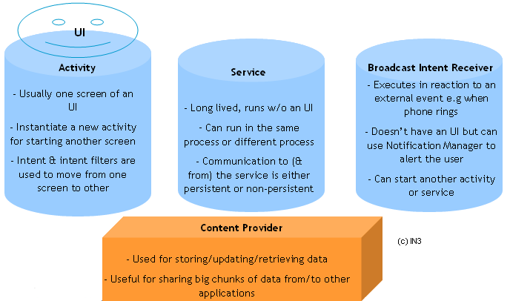

- Building blocks of an Application

    - Activity
- An activity presents a visual user interface for one focused endeavor the user can undertake.
- Though they work together to form a cohesive user interface, each activity is independent of the others.
- Each one is implemented as a subclass of the Activity base class.
- An application might consist of just one activity or it may contain several.
- Typically, one of the activities is marked as the first one that should be presented to the user when the application is launched. Moving from one activity to another is accomplished by having the current activity start the next one.
- Each activity is given a default window to draw in.
- Typically, the window fills the screen, but it might be smaller than the screen and float on top of other windows.
- An activity can also make use of additional windows — for example, a pop-up dialog or a window that presents users with vital information.
- The visual content of the window is provided by a hierarchy of views — objects derived from the base View class.
- Each view controls a particular rectangular space within the window. Parent views contain and organize the layout of their children. Leaf views (those at the bottom of the hierarchy) draw in the rectangles they control and respond to user actions directed at that space.
- Thus, views are where the activity's interaction with the user takes place.
For example, a view might display a small image and initiate an action when the user taps that image. Example of Views are buttons, text fields, scroll bars, menu items, check boxes, and more.
- A view hierarchy is placed within an activity's window by the Activity.setContentView() method. The content view is the View object at the root of the hierarchy.

    - Services
- A service doesn't have a visual user interface, but rather runs in the background for an indefinite period of time.
For example, a service might play background music as the user attends to other matters
- Each service extends the Service base class.
- A prime example is a media player playing songs from a play list. The player application would probably have one or more activities that allow the user to choose songs and start playing them. However, the music playback itself would not be handled by an activity because users will expect the music to keep playing even after they leave the player and begin something different. To keep the music going, the media player activity could start a service to run in the background. The system would then keep the music playback service running even after the activity that started it leaves the screen.
- It's possible to connect to (bind to) an ongoing service (and start the service if it's not already running). While connected, you can communicate with the service through an interface that the service exposes.
- Like activities and the other components, services run in the main thread of the application process. So that they won't block other components or the user interface, they often spawn another thread for time-consuming tasks (like music playback).

    - Broadcast Receivers
- A broadcast receiver is a component that does nothing but receive and react to broadcast announcements.
- Many broadcasts originate in system code — for example, announcements that the timezone has changed, that the battery is low, that a picture has been taken, or that the user changed a language preference.
- Applications can also initiate broadcasts — for example, to let other applications know that some data has been downloaded to the device and is available for them to use.
- An application can have any number of broadcast receivers to respond to any announcements it considers important. All receivers extend the BroadcastReceiver base class.
- Broadcast receivers do not display a user interface. However, they may start an activity in response to the information they receive, or they may use the NotificationManager to alert the user.

    - Content Providers
- A content provider makes a specific set of the application's data available to other applications. The data can be stored in the file system, in an SQLite database, or in any other manner that makes sense.
- The content provider extends the ContentProvider base class to implement a standard set of methods that enable other applications to retrieve and store data of the type it controls.
- However, applications do not call these methods directly. Rather they use a ContentResolver object and call its methods instead. A ContentResolver can talk to any content provider; it cooperates with the provider to manage any interprocess communication that's involved.

  - Activating & Shutdown Components
    - Activating Components: Intents
- The other three components — activities, services, and broadcast receivers — are activated by asynchronous messages called intents.
- An intent is an Intent object that holds the content of the message.
- For activities and services, it names the action being requested and specifies the URI of the data to act on, among other things.
For example, it might convey a request for an activity to present an image to the user or let the user edit some text.
- For broadcast receivers, the Intent object names the action being announced.
For example, it might announce to interested parties that the camera button has been pressed.

There are separate methods for activating each type of component:
- An activity is launched (or given something new to do) by passing an Intent object to Context.startActivity() or Activity.startActivityForResult().
- The responding activity can look at the initial intent that caused it to be launched by calling its getIntent() method.
- Android calls the activity's onNewIntent() method to pass it any subsequent intents.
- One activity often starts the next one. If it expects a result back from the activity it's starting, it calls startActivityForResult()instead of startActivity(). For example, if it starts an activity that lets the user pick a photo, it might expect to be returned the chosen photo. The result is returned in an Intent object that's passed to the calling activity's onActivityResult() method.
- A service is started (or new instructions are given to an ongoing service) by passing an Intent object to Context.startService(). Android calls the service's onStart() method and passes it the Intent object.
- Similarly, an intent can be passed to Context.bindService() to establish an ongoing connection between the calling component and a target service. The service receives the Intent object in an onBind() call. (If the service is not already running, bindService()can optionally start it.)
For example, an activity might establish a connection with the music playback service mentioned earlier so that it can provide the user with the means (a user interface) for controlling the playback. The activity would call bindService() to set up that connection, and then call methods defined by the service to affect the playback.
- An application can initiate a broadcast by passing an Intent object to methods like Context.sendBroadcast(),Context.sendOrderedBroadcast(), and Context.sendStickyBroadcast() in any of their variations. Android delivers the intent to all interested broadcast receivers by calling their onReceive() methods.

    - Shutting Down Components
- A content provider is active only while it's responding to a request from a ContentResolver.
- A broadcast receiver is active only while it's responding to a broadcast message. So there's no need to explicitly shut down these components.
- Activities, on the other hand, provide the user interface. They're in a long-running conversation with the user and may remain active, even when idle, as long as the conversation continues.
- Similarly, services may also remain running for a long time.
  - An activity can be shut down by calling its finish() method. One activity can shut down another activity (one it started withstartActivityForResult()) by calling finishActivity().
  - A service can be stopped by calling its stopSelf() method, or by calling Context.stopService().
- Components might also be shut down by the system when they are no longer being used or when Android must reclaim memory for more active components.

  - Others
    - The Manifest file
- Describes the components that exist in an Android application
- Principal task of the Manifest file is to inform Android about the components of an Application
- Manifest file is also bundled into the application package (.apk file)
- Structured XML file which is named AndroidManifest.xml for all the applications.

      - Key Tags in the Manifest file:
<manifest> [Root tag/node for the entire package]
<uses-permission> [Security permissions required by the package to function correctly]
<permission> [Permissions which are published by the package to restrict access for other ackages]
<instrumentation> [Declares the availability of unit test code for the package]
<application> [Contains all application level details. Only one application tag allowed in the file]
<activity> [Facility to interact with the user, typically one screen, required for launching screens ]
<intent-filter> [Declares the specific intents which the application supports]
<action> [intent action ]
<category> [Intent category]
<data> [data associated with intent eg. URI, MIME type etc]
<meta-data> [Meta-data info which can be used by users of the app for data retrieval]
<service> [Publishes service provided by the application ]
<receiver> [List of external events information which the application requires ]
<provider> [Publishes the data storage/retrieval capabilities of the application ]

      - What does Manifest file do?
- It names the Java package for the application. The package name serves as a unique identifier for the application.
- It describes the components of the application — the activities, services, broadcast receivers, and content providers that the application is composed of. It names the classes that implement each of the components and publishes their capabilities (for example, which Intent messages they can handle). These declarations let the Android system know what the components are and under what conditions they can be launched.
- It determines which processes will host application components.
- It declares which permissions the application must have in order to access protected parts of the API and interact with other applications.
- It also declares the permissions that others are required to have in order to interact with the application's components.
- It lists the Instrumentation classes that provide profiling and other information as the application is running. These declarations are present in the manifest only while the application is being developed and tested; they're removed before the application is published.
- It declares the minimum level of the Android API that the application requires.
- It lists the libraries that the application must be linked against.

Refer to this URL for more details on Android Manifest File:
http://developer.android.com/intl/de/guide/topics/manifest/manifest-intro.html

    - Intents, Intent Objects and Intent filters
For detailed information on this topic refer:
http://developer.android.com/intl/de/guide/topics/intents/intents-filters.html

      - Intents
Refer Section 4.3.1. Intents are explained in detail there.
      - Intent Object
- An Intent Object is a bundle of information
- Contains information that is usefull for the component that receives the intent. Ex: Action to be taken or Data to act on.
- Contains information that is of interest to Android platform. Ex: Category of component and instructions to Launch Etc.
An Intent object can contain any of the following:
        - Component Name
- Name of the component that should handle the Intent
- Object of type ComponentName (android.content.ComponentName)
- This is a combination of the fully qualified class name of the target component (for example "com.example.project.app.FreneticActivity") and the package name set in the manifest file of the application where the component resides (for example, "com.example.project")
- This is optional
- This is set by setComponent(), setClass(), or setClassName()
- This can be read by getComponent().

        - Action
- This is a string naming the Action to be performed
- In case of broadcast intents, the action that took place is reported
- You can define your own Action strings. It should contain the package name as prefix. Ex: com.example.project.SHOW_COLOR
- An Action in an Intent Object is set by the setAction() method and read by getAction()
- Few Action Constants that are already defined are shown in below table
Constant | Target component | Action
ACTION_CALL | activity | Initiate a phone call.
ACTION_EDIT | activity | Display data for the user to edit.
ACTION_MAIN | activity | Start up as the initial activity of a task, with no data input and no returned output.
ACTION_SYNC | activity | Synchronize data on a server with data on the mobile device.
ACTION_BATTERY_LOW | broadcast receiver | A warning that the battery is low.
ACTION_HEADSET_PLUG | broadcast receiver | A headset has been plugged into the device, or unplugged from it.
ACTION_SCREEN_ON | broadcast receiver | The screen has been turned on.
ACTION_TIMEZONE_CHANGED | broadcast receiver | The setting for the time zone has changed.
- Action Constants

        - Data
- The URI of the data to be acted on and the MIME type of that data
- For example, if the action field is ACTION_EDIT, the data field would contain the URI of the document to be displayed for editing. If the action is ACTION_CALL, the data field would be a tel: URI with the number to call.
- The setData() method specifies data only as a URI, setType() specifies it only as a MIME type, andsetDataAndType() specifies it as both a URI and a MIME type.
- The URI is read by getData() and the type by getType().

        - Category
- A string containing additional information about the kind of component that should handle the intent.
- Addition of a Category to Intent Object by calling addCategory() function
- Removal of a Category from the Intent Object by calling removeCategory() function
- getCategories() to get the set of all the categories in the Intent Object
Constant | Meaning
CATEGORY_BROWSABLE | The target activity can be safely invoked by the browser to display data referenced by a link — for example, an image or an e-mail message.
CATEGORY_GADGET | The activity can be embedded inside of another activity that hosts gadgets.
CATEGORY_HOME | The activity displays the home screen, the first screen the user sees when the device is turned on or when the HOME key is pressed.
CATEGORY_LAUNCHER | The activity can be the initial activity of a task and is listed in the top-level application launcher.
CATEGORY_PREFERENCE | The target activity is a preference panel.
- Category Constants
        - Extras
- Key-value pairs for additional information that should be delivered to the component handling the intent.
- Intent Object has a series of put…() methods and corresponding get….() methods for inserting and reading various types of extra data.
- Same as a bundle object. Bundle can be inserted into Intent Object using putExtras() and read using getExtras().

        - Flags
Flags of various sorts. Many instruct the Android system how to launch an activity (for example, which task the activity should belong to) and how to treat it after it's launched (for example, whether it belongs in the list of recent activities). All these flags are defined in the Intent class.

      - Intent Resolution
- Basically there are two types of Intents:
  - Explicit Intents: designate the target component by its name
    - Typically used for application-internal messages — such as an activity starting a subordinate service or launching a sister activity
    - Android delivers an explicit intent to an instance of the designated target class. No special strategy is required
  - Implicit Intents: do not name a target
    - Often used to activate components in other applications.
    - In the absence of a designated target, the Android system must find the best component (or components) to handle the intent
    - Android does so by comparing the contents of the Intent object to intent filters, structures associated with components that can potentially receive intents. Filters advertise the capabilities of a component and delimit the intents it can handle.
    - They open the component to the possibility of receiving implicit intents of the advertised type. If a component does not have any intent filters, it can receive only explicit intents. A component with filters can receive both explicit and implicit intents.

      - Intent Filter
- Object of the IntentFilter (android.content.IntentFilter) class. In Manifest declared by <intent-filter> tag.
- Used to inform the system which implicit intents they can handle, activities, services, and broadcast receivers can have one or more intent filters.
- Intent will be filtered either by Action or Category or Data.

- Activities & Tasks
- One activity can start another, including one defined in a different application.
- Ex:You'd like to let users display a street map of some location. There's already an activity that can do that, so all your activity needs to do is put together an Intent object with the required information and pass it to startActivity(). The map viewer will display the map. When the user hits the BACK key, your activity will reappear on screen.
- To the user, it will seem as if the map viewer is part of the same application as your activity, even though it's defined in another application and runs in that application's process. Android maintains this user experience by keeping both activities in the same task.
- A task is what the user experiences as an "application." It's a group of related activities, arranged in a stack.
- The root activity in the stack is the one that began the task - typically, it's an activity the user selected in the application launcher.
- The activity at the top of the stack is one that's currently running - the one that is the focus for user actions. When one activity starts another, the new activity is pushed on the stack; it becomes the running activity. The previous activity remains in the stack. When the user presses the BACK key, the current activity is popped from the stack and the previous one resumes as the running activity.
- A task is a stack of activities, not a class or an element in the manifest file. So there's no way to set values for a task independently of its activities. Values for the task as a whole are set in the root activity. For example, the next section will talk about the "affinity of a task"; that value is read from the affinity set for the task's root activity.
- All the activities in a task move together as a unit. The entire task (the entire activity stack) can be brought to the foreground or sent to the background. Suppose, for instance, that the current task has four activities in its stack — three under the current activity.
- The user presses the HOME key, goes to the application launcher, and selects a new application (actually, a new task).
- The current task goes into the background and the root activity for the new task is displayed. Then, after a short period, the user goes back to the home screen and again selects the previous application (the previous task).
- That task, with all four activities in the stack, comes forward. When the user presses the BACK key, the screen does not display the activity the user just left (the root activity of the previous task). Rather, the activity on the top of the stack is removed and the previous activity in the same task is displayed.
- The behavior just described is the default behavior for activities and tasks. But there are ways to modify almost all aspects of it. The association of activities with tasks, and the behavior of an activity within a task, is controlled by the interaction between flags set in the Intent object that started the activity and attributes set in the activity's <activity> element in the manifest. Both requester and respondent have a say in what happens.
In this regard, the principal Intent flags are:
FLAG_ACTIVITY_NEW_TASK
FLAG_ACTIVITY_CLEAR_TOP
FLAG_ACTIVITY_RESET_TASK_IF_NEEDED
FLAG_ACTIVITY_SINGLE_TOP
The principal <activity> attributes are:
taskAffinity
launchMode
allowTaskReparenting
clearTaskOnLaunch
alwaysRetainTaskState
finishOnTaskLaunch
More Details on Activities and Tasks can be found at
http://developer.android.com/intl/de/guide/topics/fundamentals.html#acttask

- Processes and Threads
When the first of an application's components needs to be run, Android starts a Linux process for it with a single thread of execution. By default, all components of the application run in that process and thread.

  - Process
- The process where a component runs is controlled by the manifest file. The component elements — <activity>, <service>,<receiver>, and <provider> — each have a process attribute that can specify a process where that component should run.
- These attributes can be set so that each component runs in its own process, or so that some components share a process while others do not.
- They can also be set so that components of different applications run in the same process — provided that the applications share the same Linux user ID and are signed by the same authorities. The <application> element also has a process attribute, for setting a default value that applies to all components.
- All components are instantiated in the main thread of the specified process, and system calls to the component are dispatched from that thread. Separate threads are not created for each instance. Consequently, methods that respond to those calls — methods likeView.onKeyDown() that report user actions and the lifecycle notifications always run in the main thread of the process.
- This means that no component should perform long or blocking operations (such as networking operations or computation loops) when called by the system, since this will block any other components also in the process. You can spawn separate threads for long operations.
- Android may decide to shut down a process at some point, when memory is low and required by other processes that are more immediately serving the user. Application components running in the process are consequently destroyed. A process is restarted for those components when there's again work for them to do.
- When deciding which processes to terminate, Android weighs their relative importance to the user. For example, it more readily shuts down a process with activities that are no longer visible on screen than a process with visible activities. The decision whether to terminate a process, therefore, depends on the state of the components running in that process

  - Threads
- Even though you may confine your application to a single process, there will likely be times when you will need to spawn a thread to do some background work. Since the user interface must always be quick to respond to user actions, the thread that hosts an activity should not also host time-consuming operations like network downloads. Anything that may not be completed quickly should be assigned to a different thread.
- Threads are created in code using standard Java Thread objects. Android provides a number of convenience classes for managing threads — Looper for running a message loop within a thread, Handler for processing messages, and HandlerThread for setting up a thread with a message loop.

More details on Process and Threads can be found at:
http://developer.android.com/intl/de/guide/topics/fundamentals.html#procthread

- Switching to Home Screen
    - As in most Linux based systems at start up, the boot loader loads the Linux Kernel and starts the init process.
    - Init process starts the following
      - Linux daemons
      - Zygote process
      - Runtime process
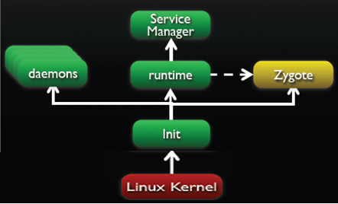
- Boot up process
- Linux daemons
  - USB Daemon (usbd) to manage USB connections
  - Android Debug Bridge (adb) to manage ADB connections
  - Debugger Daemon (debuggerd) to manage debug processes
  - Radio Interface Layer Daemon (rild) to manage wireless communication
- Zygote process
  - A nascent process which initializes a Dalvik VM instance
  - Loads classes and listens for requests to spawn new VM instances
  - Forks on request to create VM instances for managed processes
  - Copy-on-write to maximize re-use and minimize footprint
- Runtime process
  - Initializes Service Manager – the context manager that handles various service registrations and lookup
  - Registers Service Manager as default context manager for handling services
  - Runtime process sends request for Zygote for start the System Server
- System Server
  - Runtime process sends request for Zygote to start the System Server
  - Zygote froks a new VM instance for the System Server process and starts the service
  - System Service starts the native system servers e.g.
    - Surface Flinger
    - Audio Flinger
  - These native system servers then register with service manager as IPC service targets.
  - System Service also starts the application framework services e.g.
    - Window manager
    - Telephony service
    - Activity manager
    - Connectivity service
  - These android managed services also register with service manager asIPCservice targets

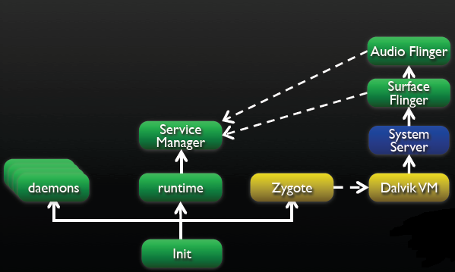
- Boot up Process - 2
- After system server loads all services, the zygote creates the “home” application in a separate process (also creates a separate instance on Dalvik VM for Home app)
- Each subsequent application then launched in its own process e.g Contacts, Media Player
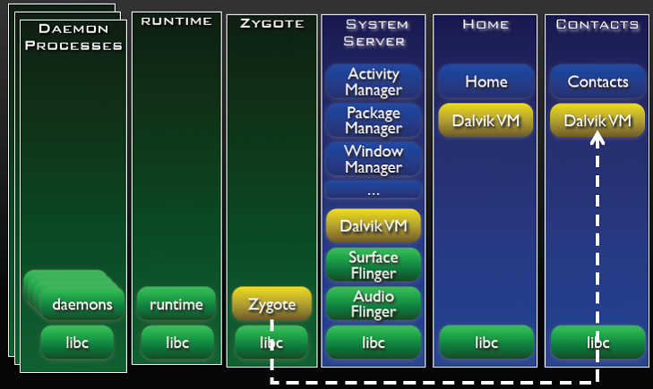
- Home Screen Launching Process

- Android SDK & Eclipse IDE setup
- Download Android SDK from http://developer.android.com/sdk/index.html
- Download Eclipse from http://www.eclipse.org/downloads/

  - System Requirements
In order to first use the Android SDK code and tools for development you will of course need a suitable environment develop from.
Currently the following operating systems are supported:
- Windows XP or Vista
- Mac OS X 10.4.8 or later (x86 only)
- Linux (tested on Linux Ubuntu Dapper Drake)
You will also need to install a suitable development environment such as:
- Eclipse 3.2, 3.3 (Europa)
- Android Development Tools plugin (optional)
- Other development environments or IDEs
- JDK 5 or JDK 6 (JRE alone is not sufficient)
- Not compatible with Gnu Compiler for Java (gcj)
- Apache Ant 1.6.5 or later for Linux and Mac, 1.7 or later for Windows

  - Installation
First you will need to download the Android SDK pack .zip archive, once downloaded find a suitable installation location on your machine and extract the zipped files.
Please note: This installation location will be referred to as $SDK_ROOT from now on through this tutorial
Alternatively you can add /tools to your root path which will prevent the need to specify the full path to the tools directory along with enabling you to run Android Debug Bridge (adb) along with other command line tools.
To add /tools:
Linux
- Edit the ~/.bash_profile or ~/.bashrc files looking for a line that sets the PATH variable.
- Add the full path location to your $SDK_ROOT/tools location for the PATH variable.
- If no PATH line exists you can add the line by typing the following:
- export PATH=${PATH}:<path to your $SDK_ROOT/tools>
Mac OS X
- In the home directory locate the .bash_profile and locating the PATH variable add the location to your $SDK_ROOT/tools folder.
Windows XP / Vista
- Right click on the My Computer icon and select the properties tab.
- Select the Advanced tab and click the Environment Variables button.
- In the new dialog box dowble-click on Path (located under System Variables) and type in the full path location to the tools directory.
The Android SDK also requires a suitable development environment to work in, here’s the installation guides for each of the supported environments.

  - Android Development Framework
If you choose to use the Eclipse IDE as your Android development environment you will have the opportunity to install and run a plug-in called Android Development Tools. ADT comes with a variety of powerful tools and extensions that will make creating, running and debugging your Android applications much easier and faster.
In order to download and install ADT you will first need to configure an Eclipse remote update, this can achieved via the following steps:
- Start Eclipse, then select Help > Software Updates > Find and Install....
- In the dialog that appears, select Search for new features to install and pressNext.
- Press New Remote Site.
- In the resulting dialog box, enter a name for the remote site (e.g. Android Plugin) and enter this as its URL: https://dl-ssl.google.com/android/eclipse/.
- Press OK.
- You should now see the new site added to the search list (and checked).
- Press Finish.
- In the subsequent Search Results dialog box, select the checkbox for Android Plugin > Eclipse Integration > Android Development Tools and press Next.
- Read the license agreement and then select Accept terms of the license agreement, if appropriate.
- Press Next.
- Press Finish.
- The ADT plugin is not signed; you can accept the installation anyway by pressingInstall All.
- Restart Eclipse.
- After restart, update your Eclipse preferences to point to the SDK root directory ($SDK_ROOT):
Select Window > Preferences... to open the Preferences panel. (Mac OS X: Eclipse> Preferences)
- Select Android from the left panel.
- For the SDK Location in the main panel, press Browse... and find the SDK root directory.
- Press Apply, then OK
    - Updating the ADT Plugin
To update the ADT plugin to the latest version, follow these steps:
- Select Help > Software Updates > Find and Install....
- Select Search for updates of the currently installed features and press Finish.
- If any update for ADT is available, select and install.
Alternatively:
- Select Help > Software Updates > Manage Configuration.
- Navigate down the tree and select Android Development Tools <version>
- Select Scan for Updates under Available Tasks.

  - How-To Use Eclipse To Develop Android Applications
In order to begin development on your Android applications you will first need to create a new Android project and then configure a launch configuration. Once completed you will have the capability to write, run and debug your Android creations.
The following sections below will provide you with the necessary instructions to get you up and running with Android provided you have installed the ADT plugin (as previously mentioned) in your Eclipse environment.
    - Creating A New Android Project
The Android Development Tools plugins kindly provides a Wizard for setting up new Projects which will allow us to create new Eclipse projects relatively quickly for either new or existing code.
Select File > New > Project
- Select Android > Android Project, and press Next
- Select the contents for the project:
- Select Create new project in workspace to start a project for new code. Enter the project name, the base package name, the name of a single Activity class to create as a stub .java file, and a name to use for your application.
- Select Create project from existing source to start a project from existing code. Use this option if you want to build and run any of the sample applications included with the SDK. The sample applications are located in the samples/ directory in the SDK. Browse to the directory containing the existing source code and click OK. If the directory contains a valid Android manifest file, the ADT plugin fills in the package, activity, and application names for you.
- Press Finish.
Once completed the ADT plugin will go ahead and create the following files and folders as appropriate for the type of project selected:
- src/ A folder that includes your stub .java Activity file.
- res/ A folder for your resources.
- AndroidManifest.xml The manifest for your project.
    - Creating A Launch Configuration For Eclipse
In order to be able to run and debug your own Eclipse applications you must first create a launch configuration. Simply, a launch config is used to specify which project to launch, which activity to start and the specific emulation options to use.
- To create a launch configuration for the application, please see the following steps:
- Select Run > Open Run Dialog... or Run > Open Debug Dialog... as appropriate.
- In the project type list on the left, right-click Android Application and select New.
- Enter a name for your configuration.
- On the Android tab, browse for the project and Activity to start.
- On the Emulator tab, set the desired screen and network properties, as well as any other emulator startup options.
- You can set additional options on the Common tab as desired.
- Press Apply to save the launch configuration, or press Run or Debug (as appropriate).

    - Running and Debugging an Eclipse Application
Once both steps 1 and 2 have been completed and your project and launch configs are up and running you will now be able to run or debug your application.
From the Eclipse main menu, select Run > Run or Run > Debug as appropriate. This command will run or debug the most recently selected application.
To set or change the active launch configuration, use the Run configuration manager, which you can access through Run > Open Run Dialog... or Run > Open Debug Dialog....
Running or debugging the application will trigger the following actions:
- Starts the emulator, if it is not already running.
- Compile the project, if there have been changes since the last build, and installs the application on the emulator.
- Run starts the application.
- Debug starts the application in "Wait for debugger" mode, then opens the Debug perspective and attaches the Eclipse Java debugger to the application.

  - Developing Android Applications with Other IDEs and Tools
Although it is recommended you use Eclipse with the Android plugin to develop your applications, the SDK also provides tools which will enable you to develop with other IDE’s including intelliJ (alternatively you could just use Eclipse without the plugin).

    - Creating an Android Project
Bundled with the Android SDK is a program called activityCreatory. activityCreator will generate a number of ‘stub’ files for your chosen project alongside a build file. This can be used to either create an Android project for new code or from existing code.
For Linux and Mac users the Android SDK provides a Python script called activityCreator.py, with Windows users receiving a btach script called activityCreator.bat. The program is used in the same way regardless of operating system.
In order to run activityCreator and create an Android project, follow these steps:
- In the command line, change to the tools/ directory of the SDK and create a new directory for your project files. If you are creating a project from existing code, change to the root folder of your application instead.
- Run activityCreator. In the command, you must specify a fully-qualified class name as an argument. If you are creating a project for new code, the class represents the name of a stub class that the script will create. If you are creating a project from existing code, you must specify the name of one Activity class in the package. Command options for the script include:
--out <folder> which sets the output directory. By default, the output directory is the current directory. If you created a new directory for your project files, use this option to point to it.
--ide intellij, which generates IntelliJ IDEA project files in the newly created project
Here's an example:
/android_linux_sdk/tools$ ./activityCreator.py --out myproject your.package.name.ActivityName
package: your.package.name
out_dir: myproject
activity_name: ActivityName
~/android_linux_sdk/tools$

The activityCreator script generates the following files and directories (but will not overwrite existing ones):
- AndroidManifest.xml The application manifest file, synced to the specified Activity class for the project.
- build.xml An Ant file that you can use to build/package the application.
- src/your/package/name/ActivityName.java The Activity class you specified on input.
- your_activity.iml, your_activity.ipr, your_activity.iws [only with the -ide intelliJ flag] intelliJ project files.
- res/ A directory to hold resources.
- src/ The source directory.
- bin/ The output directory for the build script.
Once complete you will now be able to move your folder wherever you choose for development but you’ll need to bear in mind then you will need to use the adb program in the tools folder in order to send the files to the emulator.

    - How-To Build An Android Application
Here’s how to use the Ant build.xml file generated by activityCreator to build your application.
- If you don't have it, you can obtain Ant from the Apache Ant home page. Install it and make sure it is on your executable path.
- Before calling Ant, you need to declare the JAVA_HOME environment variable to specify the path to where the JDK is installed.Note: When installing JDK on Windows, the default is to install in the "Program Files" directory. This location will cause ant to fail, because of the space. To fix the problem, you can specify the JAVA_HOME variable like this: set JAVA_HOME=c:\Prora~1\Java\. The easiest solution, however, is to install JDK in a non-space directory, for example: c:\java\jdk1.6.0_02.
- If you have not done so already, follow the instructions for Creating a New Project above to set up the project.
- You can now run the Ant build file by simply typing ant in the same folder as the build.xml file for your project. Each time you change a source file or resource, you should run ant again and it will package up the latest version of the application for you to deploy.

    - How-To Run An Android Application
In order to run a compiled application you will first need to upload the .apk file to the /data/app/ directory in the emulator using the adb tool:
- Start the emulator (run $SDK_HOME/tools/emulator from the command line)
- On the emulator, navigate to the home screen (it is best not to have that application running when you reinstall it on the emulator; press the Home key to navigate away from that application).
- Run adb install myproject/bin/<appname>.apk to upload the executable. So, for example, to install the Lunar Lander sample, navigate in the command line to $SDK_ROOT/sample/LunarLander and type ../../tools/adb install bin/LunarLander.apk
- In the emulator, open the list of available applications, and scroll down to select and start your application.
Please Note: When installing an activity for the first time you may need to restart the emulator engine in order for the activity to show up in the application launcher or before any other application can call. This is usually down to the fact that the package manager normally only examines manifests completely on emulator start-up.

    - How-To Attach a Debugger to Your Application
The following section details how to display debug information directly onto the screen (for example CPU usage). It also shows you how to hook up your IDE to debug running applications on the emulator.
The Eclipse plugin automatically attaches a debugger but you can configure other IDE’s to wait on a debugging port by doing the following:
Start the Dalvik Debug Monitor Server (DDMS) tool , which acts as a port forwarding service between your IDE and the emulator.
- Set optional debugging configurations on your emulator, such as blocking application startup for an activity until a debugger is attached. Note that many of these debugging options can be used without DDMS, such as displaying CPU usage or screen refresh rate on the emulator.
- Configure your IDE to attach to port 8700 for debugging. We’ve included information higher up on how to set up Eclipse to debug your project.

    - How-To Configure Your IDE To Attach To The Debugging Port
DDMS will automatically assign a specific debugging port for every virtual machine that it detects on the emulator. You must either attach your IDE to that port, or use a default port 8700 to connect to whatever application is currently selected on the list of discovered virtual machines.
Ideally your IDE will attach to the application running on the emulator, showing its threads and allowing you to suspend them, inspect them, or set breakpoints. If you choose to "Wait for debugger" in the Development settings panel, this will cause the application to run when Eclipse connects therefore you will need to set any breakpoints you want before connecting. If you change the application being debugged or the “Wait for debugger” then the system will kill the selected currently running application.
This can be handy if your application is in a bad state, you can simply go to the settings and toggle the checkbox to kill it.

  - Debugging Android
Google Android has a fairly extensive set of tools to help you debug your programs:
- DDMS - A graphical program that supports port forwarding (so you can set up breakpoints in your code in your IDE), screen captures on the emulator, thread and stack information, and many other features. You can also run logcat to retrieve your Log messages. See the linked topic for more information.
- logcat - Dumps a log of system messages. The messages include a stack trace when the emulator throws an error, as well as Log messages. To run logcat, see the linked topic. ...
I/MemoryDealer( 763): MemoryDealer (this=0x54bda0): Creating 2621440 bytes heap at 0x438db000
I/Logger( 1858): getView() requesting item number 0
I/Logger( 1858): getView() requesting item number 1
I/Logger( 1858): getView() requesting item number 2
D/ActivityManager( 763): Stopping: HistoryRecord{409dbb20 com.google.android.home.AllApps}
...
- Android Log- A logging class to print out messages to a log file on the emulator. You can read messages in real time if you run logcat on DDMS (covered next). Add a few logging method calls to your code.
To use the Log class, you just call Log.v() (verbose), Log.d() (debug), Log.i() (information), Log.w() (warning) or Log.e (error) depending on the importance you wish to assign the log message.
Log.i("MyActivity", "MyClass.getView() — Requesting item number " + position) You can use logcat to read these messages
- Traceview - Android can save a log of method calls and times to a logging file that you can view in a graphical reader called Traceview. See the linked topic for more information.
- Eclipse plugin - The Eclipse Android plugin incorporates a number of these tools (ADB, DDMS, logcat output, and other functionality). See the linked topic for more information.
Debug and Test Device Settings - Android exposes several settings that expose useful information such as CPU usage and frame rate.

    - Debug and Test Settings on the Device
Android enables you to set a number of options that will make it far easier to test and debug your applications.
To get to the development settings page on the emulator simply go to Dev Tools >Development Settings. This will in turn open up the development settings page with the following options (among others):
- Debug app Selects the application that will be debugged. You do not need to set this to attach a debugger, but setting this value has two effects:
It will prevent Android from throwing an error if you pause on a breakpoint for a long time while debugging.
It will enable you to select the Wait for Debugger option to pause application startup until your debugger attaches (described next).
- Wait for debugger Blocks the selected application from loading until a debugger attaches. This way you can set a breakpoint in onCreate(), which is important to debug the startup process of an Activity. When you change this option, any currently running instances of the selected application will be killed. In order to check this box, you must have selected a debug application as described in the previous option. You can do the same thing by adding waitForDebugger() to your code.
- Immediately destroy activities Tells the system to destroy an activity as soon as it is stopped (as if Android had to reclaim memory). This is very useful for testing the onFreeze(Bundle) / onCreate(android.os.Bundle) code path, which would otherwise be difficult to force. Choosing this option will probably reveal a number of problems in your application due to not saving state.
- Show screen updates Flashes a momentary pink rectangle on any screen sections that are being redrawn. This is very useful for discovering unnecessary screen drawing.
- Show CPU usage Displays CPU meters at the top of the screen, showing how much the CPU is being used. The top red bar shows overall CPU usage, and the green bar underneath it shows the CPU time spent in compositing the screen. Note: You cannot turn this feature off once it is on, without restarting the emulator.
- Show screen FPS Displays the current frame rate. Mostly useful for games to see the overall frame rate they are achieving. Note: You cannot turn this feature off once it is on without restarting the emulator.
- Show background Displays a background pattern when no activity screens are visible. This typically does not happen, but can happen during debugging.

More Details on the Android SDK will be found at http://developer.android.com/sdk/index.html

- Component Life cycles
Every android component has its own life cycle. Lets see the lifecycle of an Activity, Service and Broadcast Receiver

  - Activity Lifecycle
- An Activity has three states
- It is active or running when it is in the foreground of the screen (at the top of the activity stack for the current task). This is the activity that is the focus for the user's actions.
- It is paused if it has lost focus but is still visible to the user. That is, another activity lies on top of it and that activity either is transparent or doesn't cover the full screen, so some of the paused activity can show through. A paused activity is completely alive (it maintains all state and member information and remains attached to the window manager), but can be killed by the system in extreme low memory situations.
- It is stopped if it is completely obscured by another activity. It still retains all state and member information. However, it is no longer visible to the user so its window is hidden and it will often be killed by the system when memory is needed elsewhere.
- If an activity is paused or stopped, the system can drop it from memory either by asking it to finish (calling its finish() method), or simply killing its process. When it is displayed again to the user, it must be completely restarted and restored to its previous state.
- As an activity transitions from state to state, it is notified of the change by calls to the following protected methods:
  - void onCreate(Bundle savedInstanceState)
void onStart()
void onRestart()
void onResume()
void onPause()
void onStop()
void onDestroy()
- The entire lifetime of an activity happens between the first call to onCreate() through to a single final call toonDestroy(). An activity does all its initial setup of "global" state in onCreate(), and releases all remaining resources in onDestroy(). For example, if it has a thread running in the background to download data from the network, it may create that thread in onCreate() and then stop the thread in onDestroy().
- The visible lifetime of an activity happens between a call to onStart() until a corresponding call toonStop(). During this time, the user can see the activity on-screen, though it may not be in the foreground and interacting with the user. Between these two methods, you can maintain resources that are needed to show the activity to the user. For example, you can register a BroadcastReceiver in onStart() to monitor for changes that impact your UI, and unregister it in onStop() when the user can no longer see what you are displaying. The onStart() and onStop() methods can be called multiple times, as the activity alternates between being visible and hidden to the user.
- The foreground lifetime of an activity happens between a call to onResume() until a corresponding call to onPause(). During this time, the activity is in front of all other activities on screen and is interacting with the user. An activity can frequently transition between the resumed and paused states — for example, onPause() is called when the device goes to sleep or when a new activity is started, onResume() is called when an activity result or a new intent is delivered. Therefore, the code in these two methods should be fairly lightweight

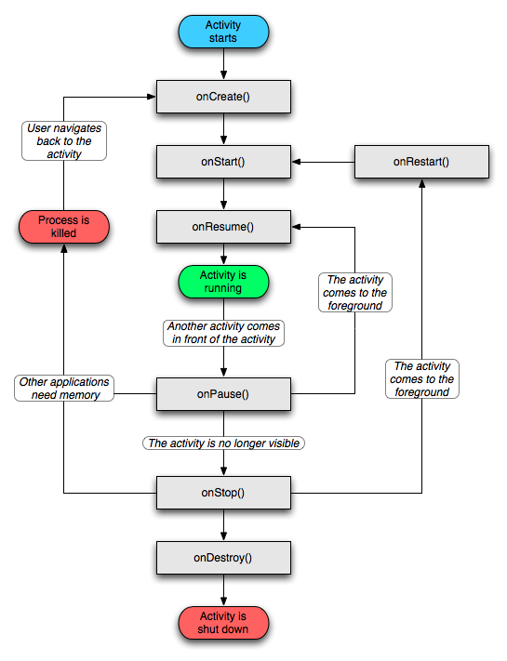
- Life Cycle of an Activity
  - Service Lifecycle
- It can be started and allowed to run until someone stops it or it stops itself. In this mode, it's started by calling Context.startService() and stopped by callingContext.stopService(). It can stop itself by calling Service.stopSelf() or Service.stopSelfResult(). Only one stopService() call is needed to stop the service, no matter how many times startService() was called.
- It can be operated programmatically using an interface that it defines and exports. Clients establish a connection to the Service object and use that connection to call into the service. The connection is established by calling Context.bindService(), and is closed by calling Context.unbindService(). Multiple clients can bind to the same service. If the service has not already been launched, bindService() can optionally launch it.
- A service has lifecycle methods that you can implement to monitor changes in its state
  - void onCreate()
void onStart(Intent intent)
void onDestroy()
- The entire lifetime of a service happens between the time onCreate() is called and the time onDestroy() returns. Like an activity, a service does its initial setup in onCreate(), and releases all remaining resources in onDestroy(). For example, a music playback service could create the thread where the music will be played in onCreate(), and then stop the thread in onDestroy().
- The active lifetime of a service begins with a call to onStart(). This method is handed the Intent object that was passed to startService(). The music service would open the Intent to discover which music to play, and begin the playback.
- There's no equivalent callback for when the service stops — no onStop() method.

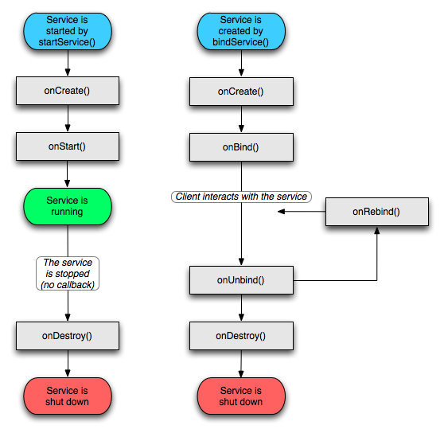
- Lifecycle of a Service
  - Lifecycle of a Broadcast Receiver
- A broadcast receiver has single callback method: void onReceive(Context curContext, Intent broadcastMsg)

  - Process and Lifecycles
1. A foreground process is one that is required for what the user is currently doing. A process is considered to be in the foreground if any of the following conditions hold:
  - It is running an activity that the user is interacting with (the Activity object's onResume() method has been called).
  - It hosts a service that's bound to the activity that the user is interacting with.
  - It has a Service object that's executing one of its lifecycle callbacks (onCreate(), onStart(), or onDestroy()).
  - It has a BroadcastReceiver object that's executing its onReceive() method.
Only a few foreground processes will exist at any given time. They are killed only as a last resort — if memory is so low that they cannot all continue to run. Generally, at that point, the device has reached a memory paging state, so killing some foreground processes is required to keep the user interface responsive.

2. A visible process is one that doesn't have any foreground components, but still can affect what the user sees on screen. A process is considered to be visible if either of the following conditions holds:
  - It hosts an activity that is not in the foreground, but is still visible to the user (its onPause() method has been called). This may occur, for example, if the foreground activity is a dialog that allows the previous activity to be seen behind it.
  - It hosts a service that's bound to a visible activity.
A visible process is considered extremely important and will not be killed unless doing so is required to keep all foreground processes running.

3. A service process is one that is running a service that has been started with the startService() method and that does not fall into either of the two higher categories. Although service processes are not directly tied to anything the user sees, they are generally doing things that the user cares about (such as playing an mp3 in the background or downloading data on the network), so the system keeps them running unless there's not enough memory to retain them along with all foreground and visible processes.

4. A background process is one holding an activity that's not currently visible to the user (the Activity object's onStop() method has been called). These processes have no direct impact on the user experience, and can be killed at any time to reclaim memory for a foreground, visible, or service process. Usually there are many background processes running, so they are kept in an LRU (least recently used) list to ensure that the process with the activity that was most recently seen by the user is the last to be killed. If an activity implements its lifecycle methods correctly, and captures its current state, killing its process will not have a deleterious effect on the user experience.

5. An empty process is one that doesn't hold any active application components. The only reason to keep such a process around is as a cache to improve startup time the next time a component needs to run in it. The system often kills these processes in order to balance overall system resources between process caches and the underlying kernel caches.

For more details on Process and Lifecycles refer
http://developer.android.com/guide/topics/fundamentals.html#lcycles

